Constructing Perpendicular Bisector

Definition
# Source: AI Source: Provided by: [Data Path: Persons Table -> ID Column: 1, Name_En Column: Motasem Essam] -> From: [ChatGPT] on [7/25/2026]
Constructing a Perpendicular Bisector is the geometric construction of a line that intersects a given line segment at its midpoint and at a right angle.
For a line segment $\overset{‾}{AB}$, its perpendicular bisector is a line $l$such that:
$$\boxed{l⊥AB}$$
and if $M$is the intersection point:
$$\boxed{AM=MB}$$
Therefore:
$$\boxed{l\text{ is the perpendicular bisector of }\overset{‾}{AB}}$$
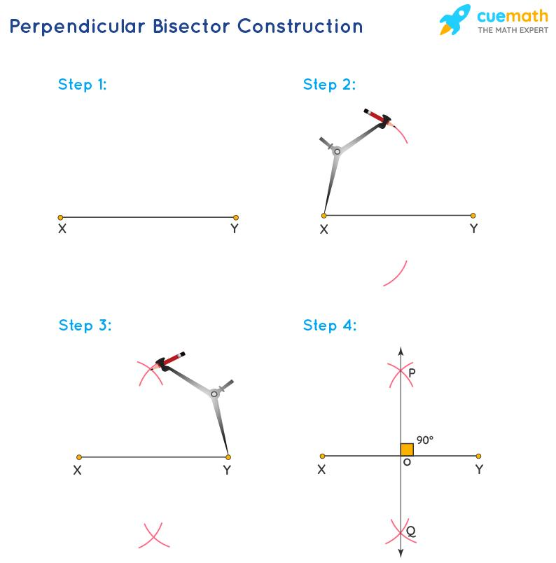
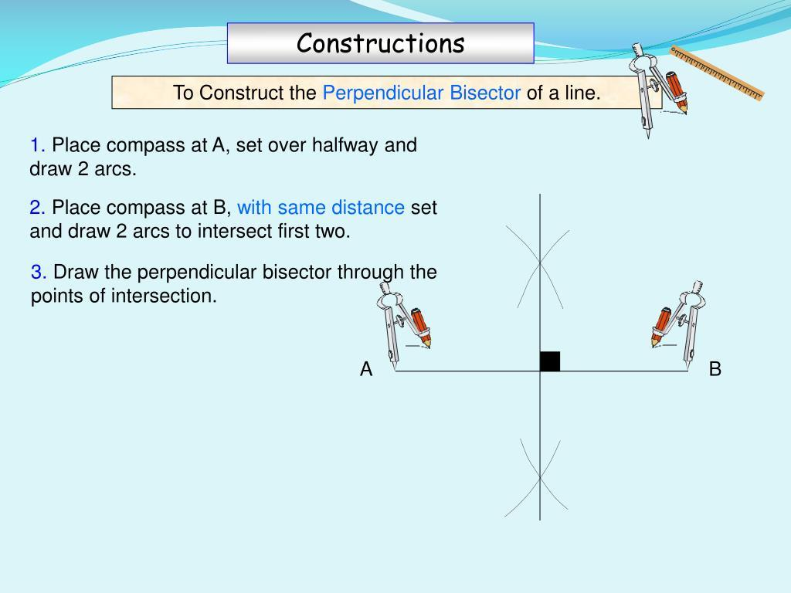
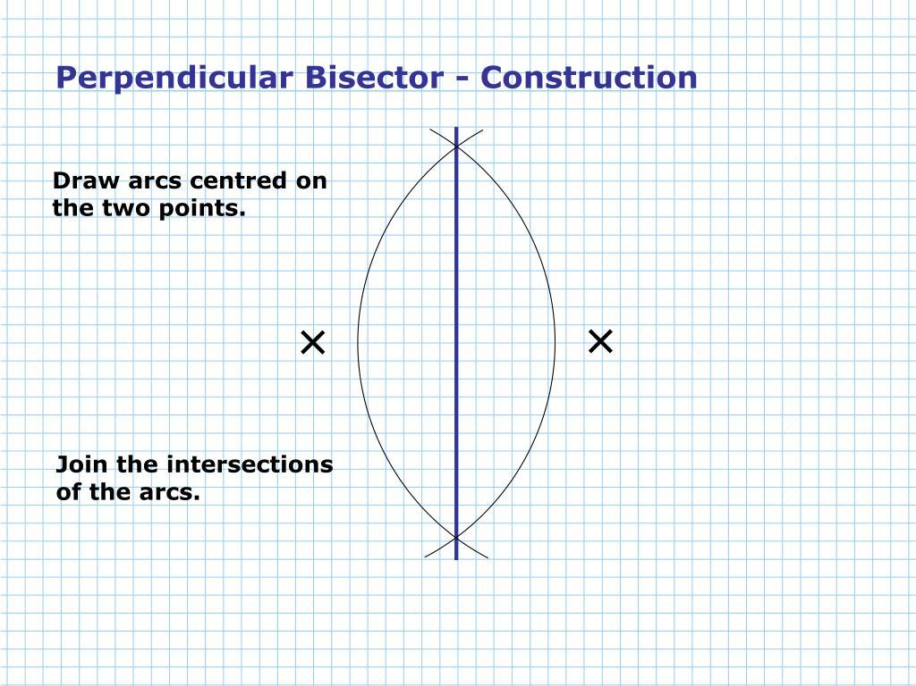
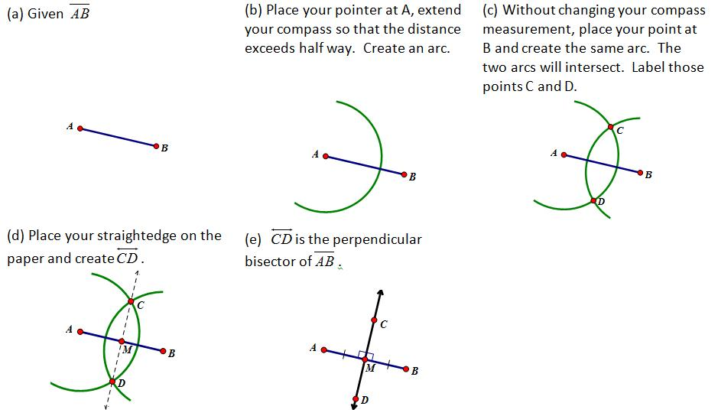
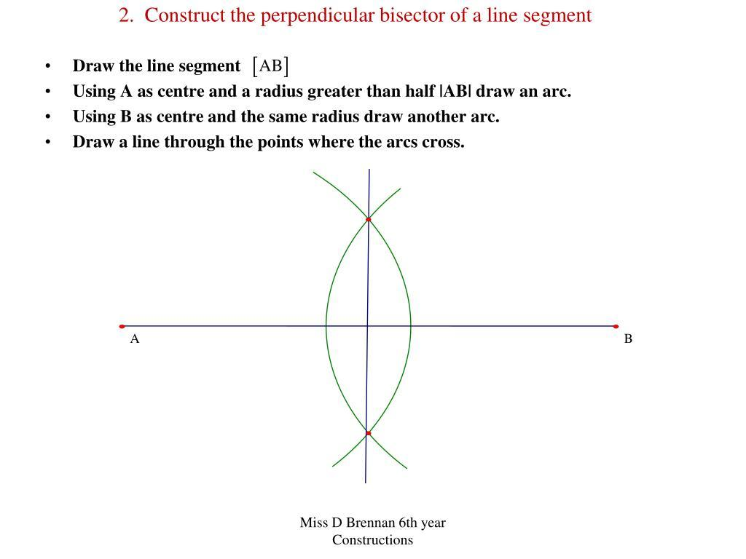
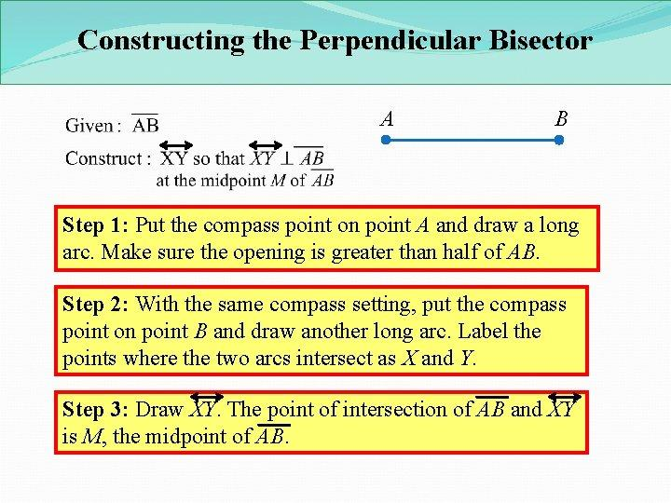

Fundamental Concept
# Source: AI Source: Provided by: [Data Path: Persons Table -> ID Column: 1, Name_En Column: Motasem Essam] -> From: [ChatGPT] on [7/25/2026]
A perpendicular bisector combines two conditions:
- It passes through the midpoint of a segment.
- It is perpendicular to the segment.
Given:
$$\overset{‾}{AB}$$
if $M$is its midpoint, then:
$$AM=MB$$
and:
$$PM⊥AB$$
Thus:
$$\boxed{\text{Perpendicular Bisector}=\text{Perpendicular Line}+\text{Bisecting the Segment}}$$

Basic Construction
# Source: AI Source: Provided by: [Data Path: Persons Table -> ID Column: 1, Name_En Column: Motasem Essam] -> From: [ChatGPT] on [7/25/2026]
Suppose $\overset{‾}{AB}$is the given line segment.
Steps
- Draw or identify the segment $\overset{‾}{AB}$.
- Open the compass to a width greater than half of $AB$.
- Place the compass point at $A$.
- Draw arcs above and below the segment.
- Without changing the compass width, place the compass point at $B$.
- Draw arcs that intersect the first pair of arcs.
- Label the two arc intersection points $P$and $Q$.
- Use a straightedge to draw the line through $P$and $Q$.
- The line $PQ$is the perpendicular bisector of $\overset{‾}{AB}$.
Therefore:
$$\boxed{PQ⊥AB}$$
and if:
$$PQ∩AB=M$$
then:
$$\boxed{AM=MB}$$
Construction Diagram
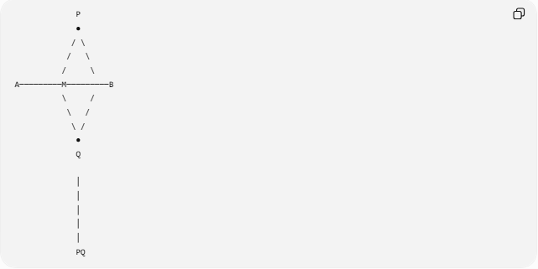
P
●
/ \
/ \
/ \
A─────────M─────────B
\ /
\ /
\ /
●
Q

│
│
│
│
│
PQ
The line $PQ$is the perpendicular bisector.

Why the Construction Works
# Source: AI Source: Provided by: [Data Path: Persons Table -> ID Column: 1, Name_En Column: Motasem Essam] -> From: [ChatGPT] on [7/25/2026]
The compass arcs are constructed with equal radii.
Therefore, point $P$is equally distant from $A$and $B$:
$$PA=PB$$
Similarly:
$$QA=QB$$
Thus, both $P$and $Q$are points that are equidistant from $A$and $B$.
The set of all points equidistant from $A$and $B$forms the perpendicular bisector of $\overset{‾}{AB}$.
Therefore:
$$\boxed{PQ⊥AB}$$
and:
$$\boxed{AM=MB}$$

Fundamental Theorem
# Source: AI Source: Provided by: [Data Path: Persons Table -> ID Column: 1, Name_En Column: Motasem Essam] -> From: [ChatGPT] on [7/25/2026]
Perpendicular Bisector Theorem
Every point on the perpendicular bisector of a line segment is equidistant from the segment's endpoints.
If $P$lies on the perpendicular bisector of $\overset{‾}{AB}$, then:
$$\boxed{PA=PB}$$
Converse
If a point $P$is equidistant from $A$and $B$:
$$PA=PB$$
then $P$lies on the perpendicular bisector of $\overset{‾}{AB}$.
Therefore:
$$\boxed{PA=PB ⟺ P\text{ lies on the perpendicular bisector of }AB}$$

Mathematical Structure
# Source: AI Source: Provided by: [Data Path: Persons Table -> ID Column: 1, Name_En Column: Motasem Essam] -> From: [ChatGPT] on [7/25/2026]
For:
$$\overset{‾}{AB}$$
with midpoint $M$:
$$\boxed{AM=MB}$$
and:
$$\boxed{PM⊥AB}$$
Therefore:
$$∠PMA=∠PMB={90}^{∘}$$
The two resulting right triangles are congruent:
$$△PMA≅△PMB$$
which confirms the symmetry of the construction.

Types of Perpendicular Bisector Construction
# Source: AI Source: Provided by: [Data Path: Persons Table -> ID Column: 1, Name_En Column: Motasem Essam] -> From: [ChatGPT] on [7/25/2026]
The construction can be organized into the following situations:
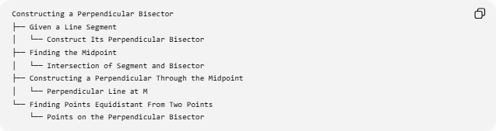
Constructing a Perpendicular Bisector
├── Given a Line Segment
│ └── Construct Its Perpendicular Bisector
├── Finding the Midpoint
│ └── Intersection of Segment and Bisector
├── Constructing a Perpendicular Through the Midpoint
│ └── Perpendicular Line at M
└── Finding Points Equidistant From Two Points
└── Points on the Perpendicular Bisector
Classification note: These are construction situations and applications of the perpendicular bisector rather than separate mathematical types of perpendicular bisectors.

Perpendicular Bisector vs Perpendicular Line
# Source: AI Source: Provided by: [Data Path: Persons Table -> ID Column: 1, Name_En Column: Motasem Essam] -> From: [ChatGPT] on [7/25/2026]
These constructions are related but not identical.
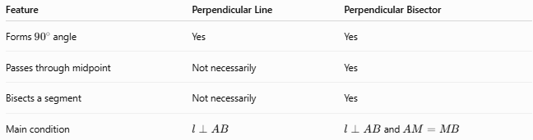
Feature | Perpendicular Line | Perpendicular Bisector
Forms ${90}^{∘}$angle | Yes | Yes
Passes through midpoint | Not necessarily | Yes
Bisects a segment | Not necessarily | Yes
Main condition | $$l⊥AB$$ | $l⊥AB$and $AM=MB$
Therefore:
$$\boxed{\text{Every perpendicular bisector is a perpendicular line}}$$
but:
$$\boxed{\text{Not every perpendicular line is a perpendicular bisector}}$$

Perpendicular Bisector vs Angle Bisector
# Source: AI Source: Provided by: [Data Path: Persons Table -> ID Column: 1, Name_En Column: Motasem Essam] -> From: [ChatGPT] on [7/25/2026]
These two constructions use the word bisector, but they bisect different geometric objects.
Perpendicular Bisector
Bisects a line segment:
$$AM=MB$$
and is perpendicular to it:
$$PM⊥AB$$
Angle Bisector
Bisects an angle:
$$∠ABD=∠DBC$$
Therefore:
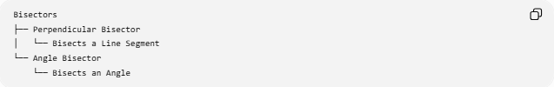
Bisectors
├── Perpendicular Bisector
│ └── Bisects a Line Segment
└── Angle Bisector
└── Bisects an Angle

Applications
# Source: AI Source: Provided by: [Data Path: Persons Table -> ID Column: 1, Name_En Column: Motasem Essam] -> From: [ChatGPT] on [7/25/2026]
Perpendicular bisectors are used in many geometric constructions.
1. Finding the Midpoint
The intersection of the perpendicular bisector with the segment gives its midpoint.
$$\boxed{AM=MB}$$
2. Finding Points Equidistant From Two Points
Any point on the perpendicular bisector satisfies:
$$\boxed{PA=PB}$$
3. Constructing a Circumcenter
The perpendicular bisectors of the sides of a triangle intersect at the circumcenter.
For triangle $ABC$:
$$\boxed{\text{Circumcenter}=\text{intersection of perpendicular bisectors}}$$
4. Constructing a Circumcircle
Once the circumcenter $O$is found:
$$OA=OB=OC$$
A circle centered at $O$through any vertex passes through all three vertices.

Tools Used
# Source: AI Source: Provided by: [Data Path: Persons Table -> ID Column: 1, Name_En Column: Motasem Essam] -> From: [ChatGPT] on [7/25/2026]

Tool | Purpose
Compass | Draw equal-radius arcs
Straightedge | Draw the perpendicular bisector
Both | Complete the classical construction
The compass is essential for establishing equal distances from the segment's endpoints.

Important Conditions
# Source: AI Source: Provided by: [Data Path: Persons Table -> ID Column: 1, Name_En Column: Motasem Essam] -> From: [ChatGPT] on [7/25/2026]
For the standard compass construction, the compass radius should satisfy:
$$\boxed{r>\frac{AB}{2}}$$
This ensures that the arcs centered at $A$and $B$intersect.
If:
$$r=\frac{AB}{2}$$
the arcs meet only at the midpoint and do not provide two distinct intersection points for drawing the bisector.
If:
$$r<\frac{AB}{2}$$
the arcs do not intersect.

Classification Summary
# Source: AI Source: Provided by: [Data Path: Persons Table -> ID Column: 1, Name_En Column: Motasem Essam] -> From: [ChatGPT] on [7/25/2026]
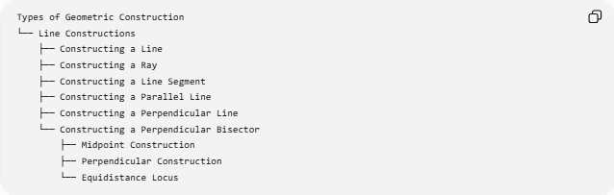
Types of Geometric Construction
└── Line Constructions
├── Constructing a Line
├── Constructing a Ray
├── Constructing a Line Segment
├── Constructing a Parallel Line
├── Constructing a Perpendicular Line
└── Constructing a Perpendicular Bisector
├── Midpoint Construction
├── Perpendicular Construction
└── Equidistance Locus

Key Points
# Source: AI Source: Provided by: [Data Path: Persons Table -> ID Column: 1, Name_En Column: Motasem Essam] -> From: [ChatGPT] on [7/25/2026]
- A perpendicular bisector divides a line segment into two equal parts.
- It intersects the segment at ${90}^{∘}$.
- If $M$is the midpoint:
$$\boxed{AM=MB}$$
- The bisector is perpendicular to the segment:
$$\boxed{PM⊥AB}$$
- Every point on the perpendicular bisector is equidistant from the endpoints:
$$\boxed{PA=PB}$$
- The classical construction uses a compass and straightedge.
- The compass radius must be greater than half the segment length.
- Perpendicular bisectors are fundamental in constructing midpoints, circumcenters, and circumcircles.

Conclusion
# Source: AI Source: Provided by: [Data Path: Persons Table -> ID Column: 1, Name_En Column: Motasem Essam] -> From: [ChatGPT] on [7/25/2026]
Constructing a Perpendicular Bisector is the process of constructing a line that passes through the midpoint of a given line segment and intersects it at a right angle. The classical construction uses equal-radius arcs from both endpoints of the segment and a straightedge to connect their intersection points. The resulting line is simultaneously a perpendicular line, a bisector of the segment, and the locus of points equidistant from the segment's endpoints.

